Move Block – Tutorial 1

# Tutorial Question 1

## Moving Straight

1. Move forward 5 rotations in a straight line. Use the block in Figure 1.

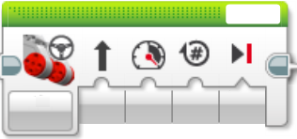

Figure 1 - Move Steering Block.

1. Move forward 5 rotations in a straight line. Use the block in Figure 2.

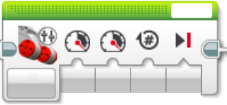

Figure 2 - Move Tank Block.

# Tutorial Question 2

## Turning

1. Move forward 2 rotations, turn left in one spot as shown in Figure 3. Then move forward 1 rotation. Use the block in Figure 4 to turn.

*Hint – What happens if the power on the left and right motors are different?*

Figure 3 - 90 Degree turn.



Figure 4 - Move Tank Block.

1. Repeat part a using the block in. *Hint – What happens if the direction is very high?*



Figure 5- Move Steering Block.

1. Make the turn shown in Figure 6 using the block shown in Figure 7.

Figure 6 - Slow 90 Degree Turn.



Figure 7 - Move Steering Block.

1. Repeat part c using the block shown in Figure 8.



Figure 8 - Move Tank Block.

# Challenge Problem.

Can you match the movement shown in Figure 9.

Figure 9 - Challenge problem map.